**PRODUCT MANUAL**



**Product Name : guildKraft**

**Version : 1.1(Beta)**

**.**

## GLOSSARY

|  |  |
| --- | --- |
| **LEGEND** | |
| **TERM** | **DEFINITION** |
| **BP** | Business Process |
| **U** | User |
| **F** | Functional |
| **EID** | Enterprise Integration Dashboard |
| **SOA** | Service Oriented Architecture |
| **dB** | digiBlitz |
| **FNA** | Finance and Accounting |
| **SME** | Subject Matter Expert |
| **KPI’s** | Key Performance Indicators |
| **KRA’s** | Key Result Areas |
| **ERP** | Enterprise Resource Planning |
| **XML** | Extra Mark Up Language |
| **CRM** | Customer Relationship Management |
| **BPM** | Business Process Management |

CONTENTS

GLOSSARY 2

1 INTRODUCTION………………………………………………………………...4

1.1 4

1.2 Scope 4

1.3 Background 4

1.4 Traceability Matrix 5

1.5 Assumptions and Constraints 5

1.6 Document Overview 5

2 METHODOLOGY………………………………………………………………..6

3 FUNCTIONAL REQUIREMENTS………………………………………………7

3.1 Context…………………………………………………………………………….7

3.2 User Requirements…………………………………………………………………7

3.3 Data Flow Diagrams………………………………………………………………15

4 Logical Data Model/Data Dictionary…………………………………………….21

5 Functional Requirement………………………………………………………….21

6 OTHER REQUIREMENTS……………………………………………………..25

6.1 Interface Requirements 26

6.2 Data Conversion Requirements -Details in FDD 27

6.3 Hardware/Software Requirements 27

6.4 Operational Requirements- Will be Updated Later 27

7 References 31

# INTRODUCTION

# Transform your ad-hoc staffing functions into an effective automated business process through digiBlitz guildKraft

guildKraft helps your organization's contingent workforce Business Automation using BPM & SOA technologies. It is powered by dBETE platform which helps you to successfully implement your Business-Technology Landscape transformation projects. The solution is specifically tailor made for staffing industry.

**Basic Concepts:**

**Enterprise application development using J2EE,Web services**

The guildKraft Application is developed various Technologies with a mould package.

**Enterprise Application Integration**

The Enterprise Application Integration which the Mould Package is full of Integrated functionalities.

**BPM/BPEL Technical Development and Integration**

A business process can be anything from processing a customer order,. It is the set of steps taken in our day to day work activities that is performed to accomplish a desired outcome

**Type of Business Process:**

1. **Operational Process**

Operational Process is also considered 'core value streams' or 'primary processes', are those processes that are central to the design, production and delivery of a company’s products and services

1. **Process Improvement**

There are many workforce and business system inefficiencies today that can easily lead to to problems such as poor quality of service and resulting customer satisfaction, unnecessary costs, and employee morale issues. Often, you can directly tie these issues and problems to poor understanding, measurement. So our digiblitz ELMT BPM is the better understanding of processes (through techniques such as mapping/documenting processes and workflows)

**Process Automation**

Some processes but not all can also benefit from the use of digiBlitz ELMT Business Process A combination of workflow automation, integration, monitoring and management tools, and Mensch Force platforms can offer very significant benefits. They can automate workflow and orchestrate processes, reduce risk of errors, provide metrics and visibility into status; enforce deadlines; validate, properly route and synchronize data; reduce training costs and provide other benefits as well.

These improvements can add up to a very serious positive impact on a business's bottom line.

**SOA Technical Development and Integration**

In SOA you will learn the basic concepts of,

* Enterprise Application
* Webservice to the Rescue
* What is Service Oriented Architecture?
* Business and Integration

**Enterprise Integration:**

digiBlitz ELMT Product is an integration framework composed of a collection of technologies and services which form a middleware to enable integration of systems and applications across an enterprise.

digiBlitz ELMT is Integrated with Multiple Application such as supply chain management applications, ERP systems, CRM applications for managing customers, payroll and human resources systems typically cannot communicate with one another in order to share data or business rule.

* Described by Process Automation/Workflow
* Adapters interface with applications at their integration points
* Transformers change data and/or message format
* Enterprise Integration Server provides runtime

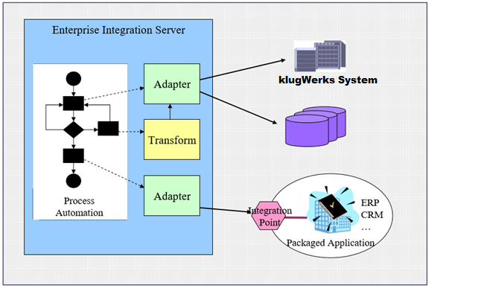

Fig: Enter Integration Application Package

1. **Web Services to the Rescue?**

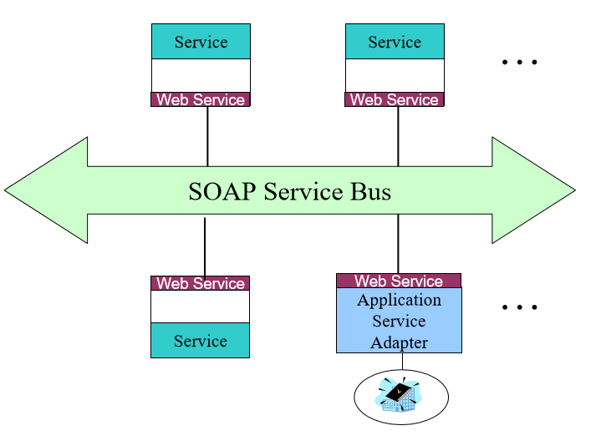

1. **What is an SOA?**

SOA is concerned with the independent construction of services which can be combined into meaningful, higher level business processes within the context of the enterprise.

A Service Oriented Architecture describes several aspects of services within an enterprise:

• The granularity and types of services

• How services are constructed

• How the services communicate at a technical level

• How the services are combined together (i.e. orchestrated)

• How the services interoperate at a semantic level (i.e. how they share common meanings)

• How services contribute to IT and Business Strateg

**We’re all on this Service Bus**

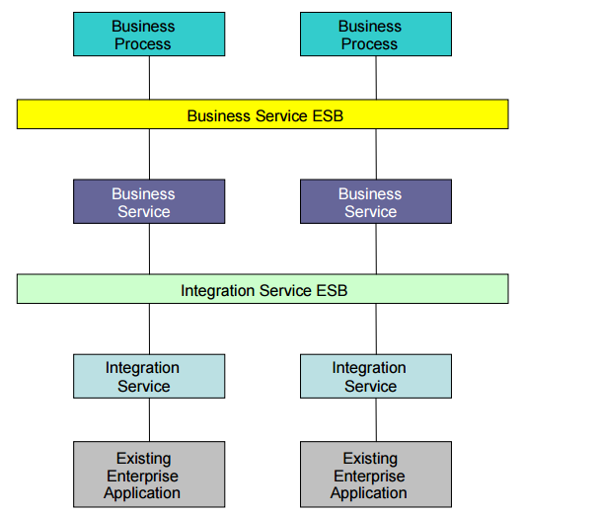

**Cloud Computing and Big Data**

1. **Cloud Computing**
2. **What is Cloud Computing?**
3. **Delivering applications and services over the Internet**

* Software as a service

1. **Extended to:**

* Infrastructure as a service: Amazon EC2
* Platform as a service: Google AppEngine, Microsoft Azure

1. **Utility Computing:** pay-as-you-go computing

* Illusion of infinite resources
* No up-front cost
* Fine-grained billing (e.g. hourly)

1. **Cloud Computing: Why Now?**
2. **Experience with very large datacenters**

* Unprecedented economies of scale
* Transfer of risk

1. **Technology factors**

* Pervasive broadband Internet
* Maturity in Virtualization Technology

1. **Business factors**

* Minimal capital expenditure
* Pay-as-you-go billing model

1. **Big DATA**
2. **Introduction:**

* Big Data may well be the Next Big Thing in the IT world.
* Big data burst upon the scene in the first decade of the 21st century.
* The first organizations to embrace it were online and startup firms. Firms like Google, eBay, LinkedIn, and Facebook were built around big data from the beginning.
* Like many new information technologies, big data can bring about dramatic cost reductions, substantial improvements in the time required to perform a computing task, or new product and service offerings.

1. **What id Big Data?**

* ‘Big Data’ is similar to ‘small data’, but bigger in size
* But having data bigger it requires different approaches:
  + Techniques, tools and architecture
* An aim to solve new problems or old problems in a better way Big Data generates value from the storage and processing of very large quantities of digital information that cannot be analyzed with traditional computing techniques.
* Walmart handles more than 1 million customer transactions every hour.
* Facebook handles 40 billion photos from its user base.
* Decoding the human genome originally took 10years to process; now it can be achieved in one week.

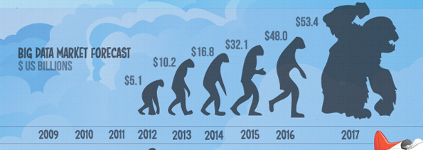

1. **Why Big Data?**

* Growth of Big Data is needed
* Increase of storage capacities
* Increase of processing power
* Availability of data(different data types)
* Every day we create 2.5 quintillion bytes of data; 90% of the data in the world today has been created in the last two years alone

**Data generation points Examples**

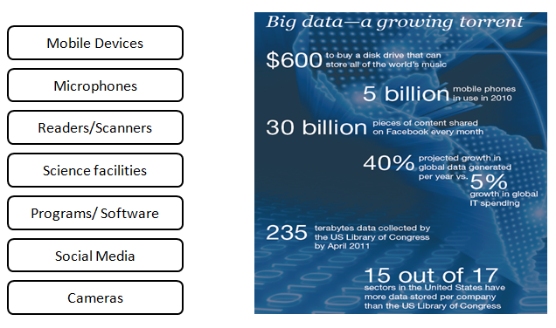

**Event Driven Program and State Machine Integration:**

A state machine is a programming architecture that can be used to implement any algorithm that can be explicitly described by a state diagram or flowchart.

A state machine consists of a set of states and a case selector that determines which state the program transitions to next.

### Simple Example

Here is a simple example that demonstrates the functionality and structure of a state machine. This example computes the cumulative result of simple arithmetic operations between the previous cumulative result and a constant. The arithmetic operation is decided by the user through an enumerated control (enum). The value of this enum is what decides which case to enter in each iteration of the while loop.

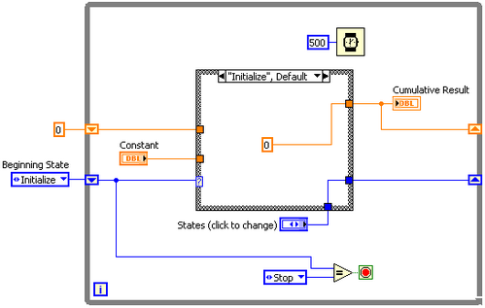

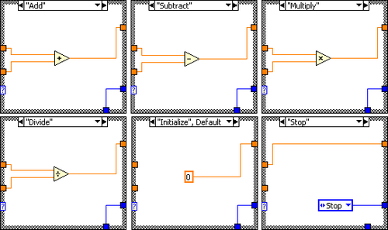

**ELMT Platform Introduction and Development**

**Overview**

The ELMT for digiBlitz provides a platform for Performing Architecture Planning and implement which helps digiBlitz in managing business transformation very well.

Enterprise Business Transformation via ELMT is done by packaging Artifact Management Module, Business Process Management Module, collaboration, supplier management, Training modules, CRM, webstore, ERP, SOA/ESB and Governance Modules.

The very basic methodology based on which the entire requirement is created is ELMT-Framework of digiBlitz. The following diagram shows the Framework of digiBlitz.

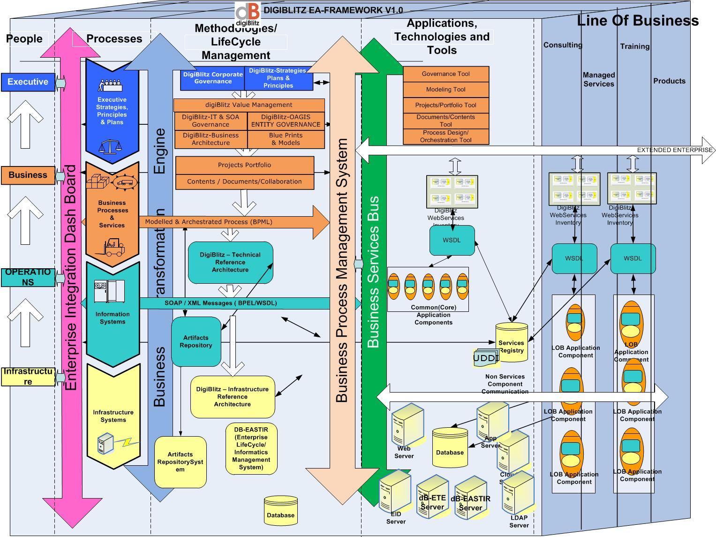

**ELMT Based Solution**

**New Features and Functionalities in ELMT-0.1**

Added the following modules to support the Enterprise Business transformation:

1. Business Process Management
2. Artifact Management
3. Functional Management
4. Role Management
5. Lifecycle Management
6. Service Management

**Login Module**

This is the entry level of the system. User need to login the system using the login. For the new user need to click the **New user signup** link.

**Sign Up**

For the new user registration user need to click register button.

User need to registered the own details to system and create the username and password.

**Sign In**

Once administrator approved your registration, you will get the detailed mail with username and password. Using that username and password you can login to the system.

After login into the system with valid username and password

Now the users have no permission to access any application because the users don’t have any role. So you need to have a role from administrator.

**1. Business Process Management**

Process management is used to create a new process, Build the process and deploy the build process. And this process management is accessed by admin, process manager, developer and designer.

**2. Artifact Management**

The Artifact Traversing and Retrieval System will be based on the following considerations.

1. Please refer to the accompanying diagram for a simplified visual representation. (Artifacts are represented in purple text as SV1, SVBP1, SVBPD1….etc.)
2. The first version of IED will feature statically linked artifacts and manual traversing.
3. Refer to diagram given below to understand the following steps:
4. User chooses Strategic View and selects artifact SV1.
5. Artifacts SVBP1 and SVBP3 in the next level are both related to SV1. So when the user selects SV1, the links to SVBP1 and SVBP3 are presented on the right side of the page.
6. The user can then choose to further click on SVBP1 or SVBP3 depending on his needs.
7. This will in turn display more artifacts that may be related to each subsequent choice by the user.
8. Subsequent versions of the IED will incorporate more sophisticated search and traversing algorithms such as Huffman’s algorithm or Markov Chain to retrieve artifacts more efficiently.
9. The user will have the ability to view as well as edit artifacts in the current version of IED. HP Systinet will be used to perform user validation and IBM Clear Case or a custom versioning tool will be used to manage changes to artifacts.
10. Each artifact can also be considered as a node in the tree. A node can be represented as shown below.

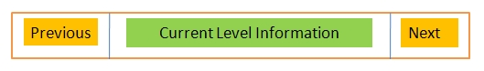

1. An artifact will contain information of the current state, and also information about related artifacts at the next and previous level.
2. A dependency table / matrix will be maintained to manage interdependencies between the artifacts.
3. New artifacts may be added to the tree as long as they confirm to the conditions specified in (e). Only the administrator / repository manager will have this ability for this version of IED.
4. As the user goes down each level, any artifact accessed by the user will cause the system to identify related artifacts and provide a link to all related artifacts on the next level. Therefore, the specific artifacts that can be retrieved will be decided based on user input at each level or node.
5. Given below is a simple flow diagram showing the artifacts at the various levels.

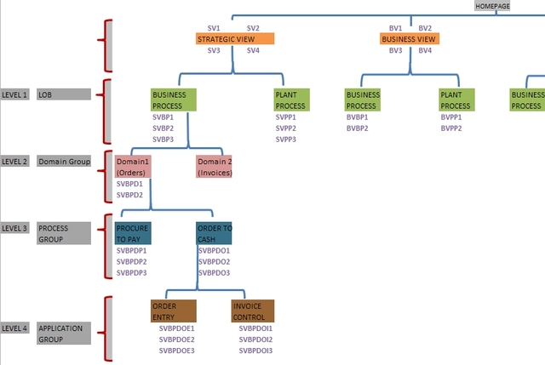

**3. Functional Management**

Functional management is the most common type of organizational management. The organization is grouped by areas of specialty within different functional areas

**4. Role Management**

Role Management is used to assign role to newly registered user, mapping the entity, privileges and permissions to the roles and also able to (create, edit and delete) the (role, entity, privileges, permission). And this role management is only accessed by the **Admin.**

Only the Admin role has a permission to access the all entities and privileges in this system.

Because this role will control all other roles which are present in this system.

The available privileges and permission in Role Management

1. Manage Role
   1. Assign Roles Securities
   2. Assign Roles to User
   3. Maintain Roles
   4. Mapping Role with Entities
2. Manage Entity
   1. Create Entity
   2. Edit List of Entities
   3. View List of Entities
3. Privilege
   1. Create Privilege
   2. Edit List of Privilege
   3. View List of Privilege
4. Permission
   1. Create Permission
   2. Edit List of Permission
   3. View List of Permission
5. Manage Mapping
   1. Mapping Entity with Privileges
   2. Mapping Privileges with Permission
   3. Mapping Role with Entities
   4. Mapping Role with Entities and Privileges

**Manage Role:**

This privilege is used to manage the roles and securities for the registered user (i.e.) assign the role to user. For example

**How to assign roles to user:**

Click **ASSIGN ROLE TO USER** option in the **Manage Role** drop down this will redirect into Search Member page

**Maintain Roles**

By using the maintain role admin can able to create a new role, edit a role and also delete a role.

In the index page of admin click the **Maintain Roles** option in the Manage role drop down, this will redirect into Maintain Roles page

1. **Create a role:**

Here if admin want to create new role click **Add** button in the Maintain Roles page, this will redirect into create new role page

1. **Edit a role:**

If the admin want to edit the already created role, need to check the any one available role and click the **Edit** button in the Maintain Roles page, this will redirect into edit role page.

1. **Delete a role:**

For delete an existing role admin need to check the any one of available role in the maintain role page and click the **Delete** button. After clicking the **Delete** button the respective role will be deleted from the database.

**Edit/view entity:**

If the admin want to view/edit an entity, need to click the **View/Edit List of Entity** option in the Manage entity drop down.

**Privilege:**

Privilege is used to give some permission to users for accessing this system module. This is only assigned by the administrator. Here admin can able to create, Edit and View the privileges.

1. **Create Privilege:**

Click the **Create Privileges** option in the **Privilege** drop down of Role Management’s index page.

1. **Edit/View List of Privilege:**

If the admin want to view/edit a privilege, need to click the **View/Edit List of Privilege** option in the Privilege drop down

**Permission:**

Permission is used to give some access control to users for accessing this system module. This is only assigned by the administrator. Here admin can able to create, Edit and View the Permission.

1. **Create Permission:**

Click the **Create Permission** option in the **Permission** drop down of Role Management’s index page.

1. **Edit/View List of Permission:**

If the admin want to view/edit Permission, need to click the **View/Edit List of Privilege** option in the Permission drop down.

**Manage Mapping:**

This option is used to mapping the Roles, Entities, Privilege and Permission with each other. This will only assigned by the administrator.

1. **Mapping Entity with Privileges:**

Here admin can able to map the Entity with the Privileges. For this click the Mapping Entity with privileges Option in the Manage Mapping drop down.

1. **Mapping Privilege with Permission:**

Here admin can able to map the Privileges with the Permission. For this click the Mapping privileges with Permission Option in the Manage Mapping drop down.

1. **Mapping Role with Entities:**

Here admin can able to map the Role with the Entities. For this click the Mapping Role with Entities Option in the Manage Mapping drop down.

1. **Mapping Role with Entities and Privileges:**

Here admin can able to map the Role with the Entities and Privileges. For this click the Mapping Role with Entities and Privileges Option in the Manage Mapping drop down.

**5. Life cycle Management**

Lifecycle management is used to create a lifecycle process for the business processes.

**6. Service Management**

This module is used to start the service oriented governance lifecycle and also it has a control to approve and deny the created lifecycle service.